**HTML, CSS AND JAVASCRIPT:**

**THE BIG PICTURE**

## how you should care about how the web works

### A look Into the history of the web

### how the magic of the web works

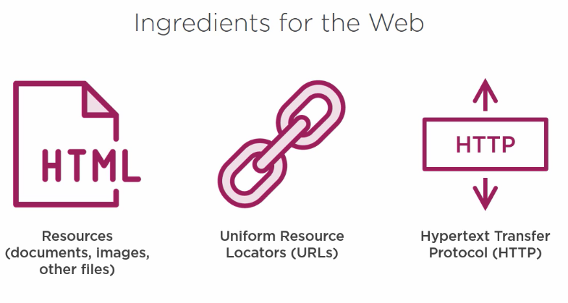

Retrieve document and communicate them to your web browser

The uniquely identify the resources so that web browser ultimately show them to you or download the. Every the resource on the web has a uniquely url

* How to it work

Documents, like HTML document and other resources like images, are hosted on a web server, this is just a computer, like your own computer or laptop but it run special software that enable to it serve up the HTML documents and other resources. The web server will have a unique address to the internet, a URL.

Then web browser ask the internet to serve up a specific documents that lives at the address of a given URL

The HTTP protocol take care of the information communication between the web browser and the web server to get actually document or send document back

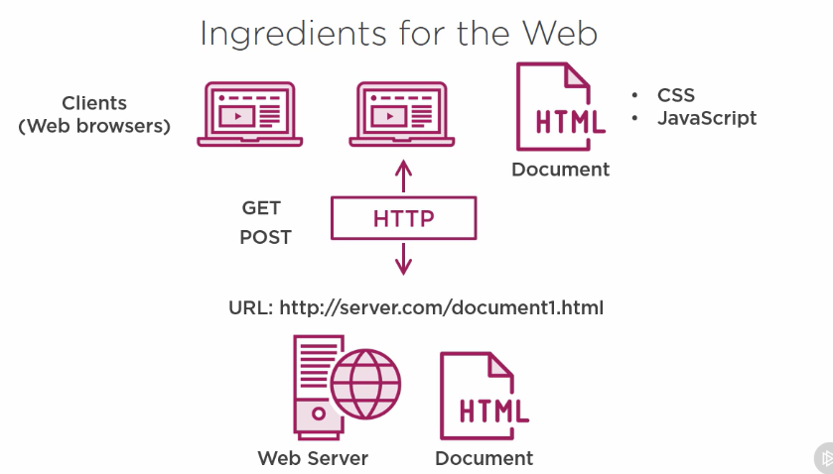

### Why learn about HTML, CSS and JavaScript

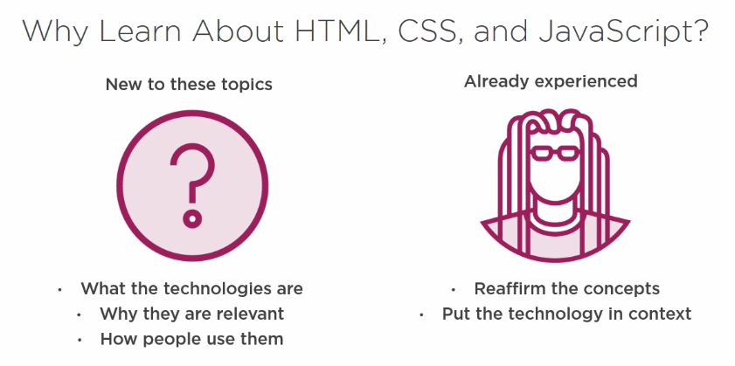

### Thing to remember

* 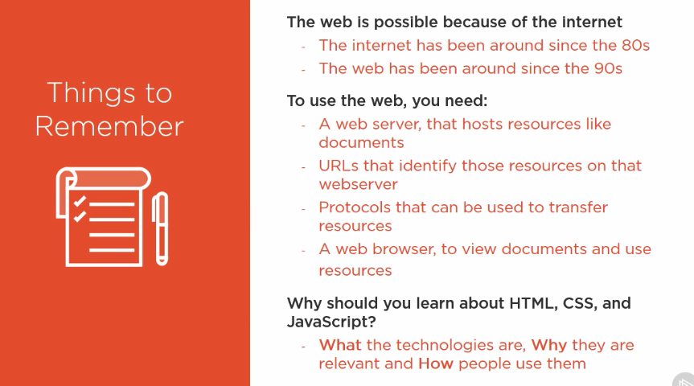

## Displaying the web with HTML

### Where this HTML come from

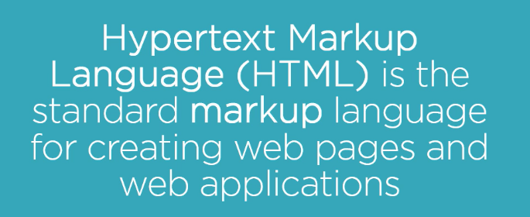

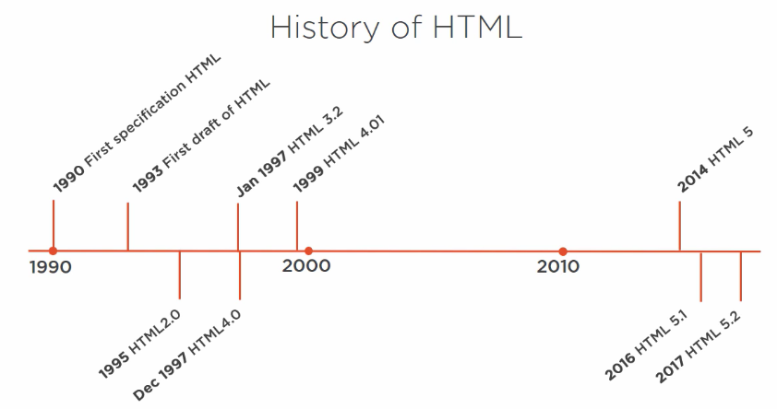

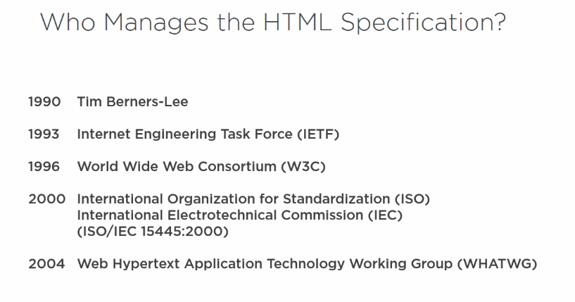

### what is HTML

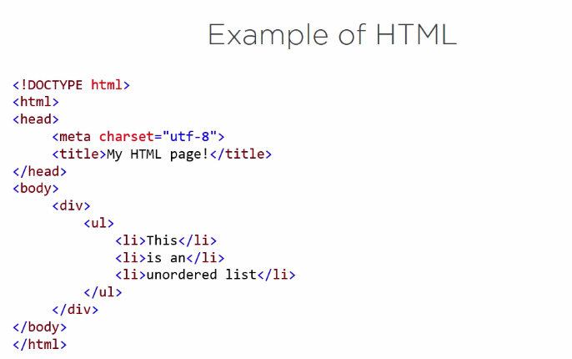

Tell browser that the character encoding that is used in the document is UTF-8

### working with HTML

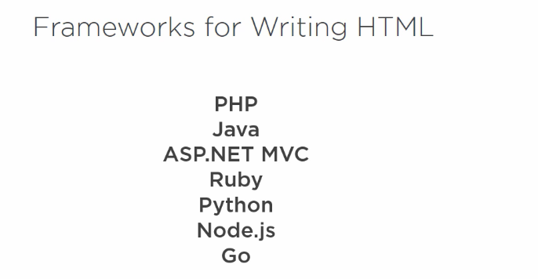

## Styling the web with css

### where did css come from?

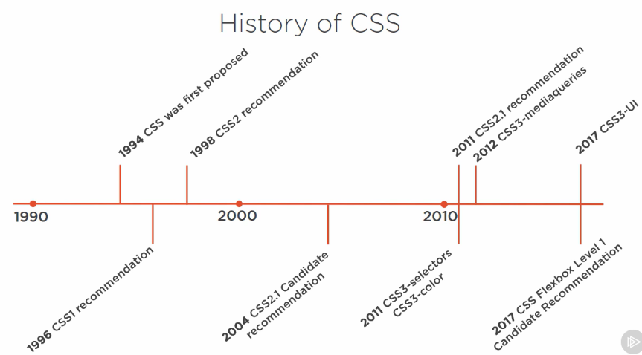

* what is CSS?

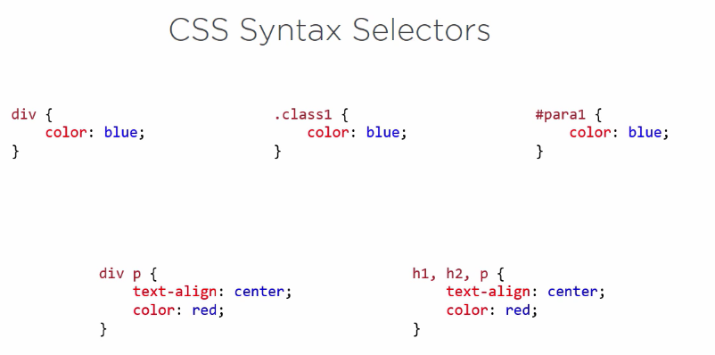

ID

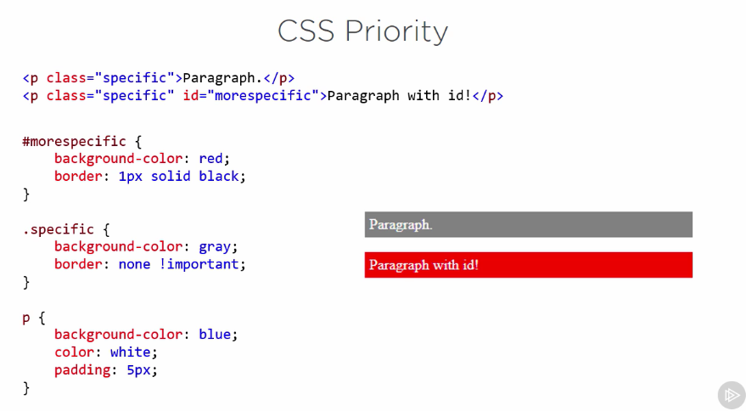

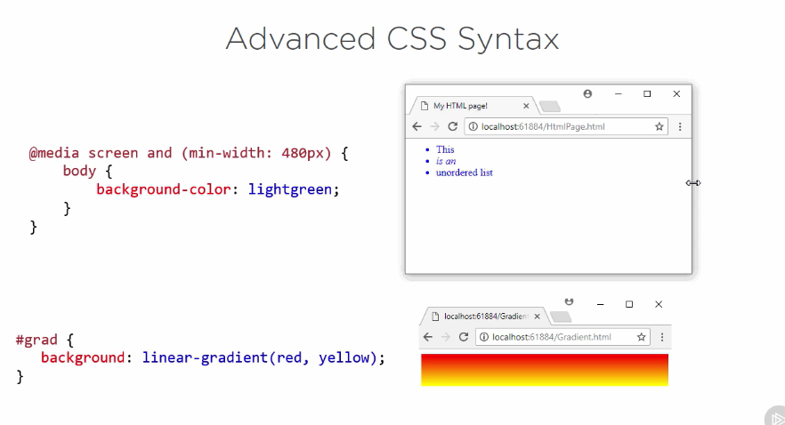

### working with CSS

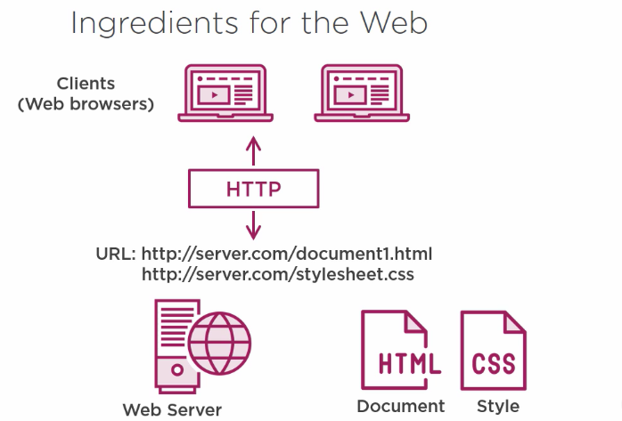

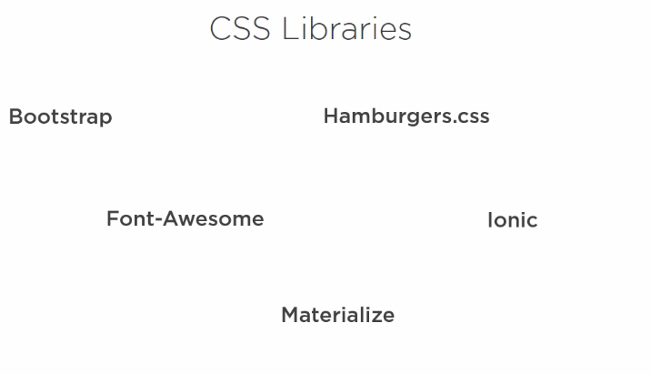

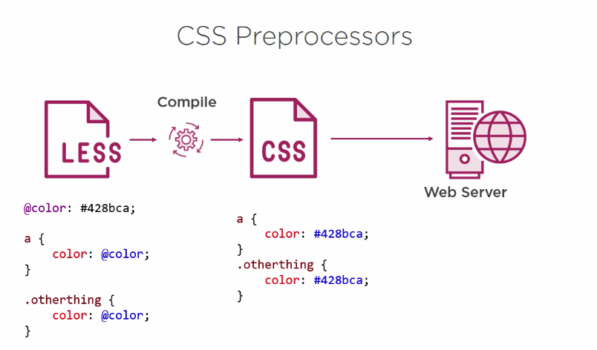

### thing to remember

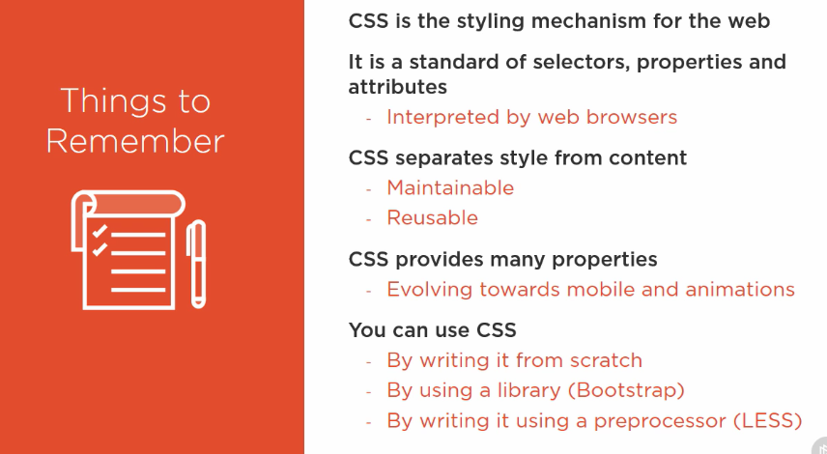

## Interacting with the web with javascript

### where did javaScript come from?

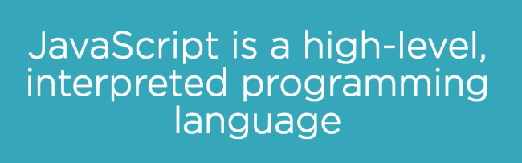

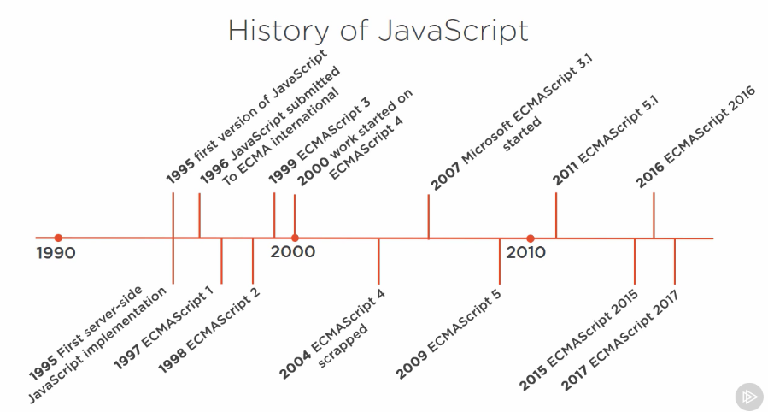

### what is JavaScript?

### Working with JavaScript

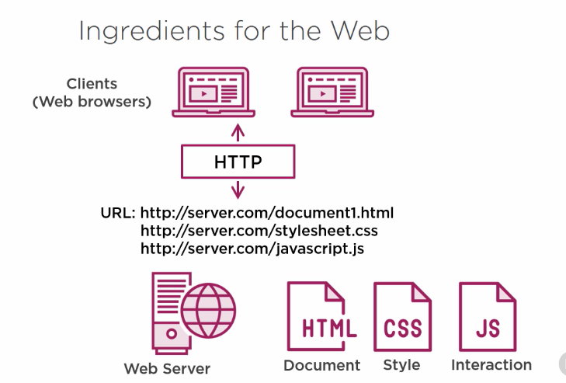

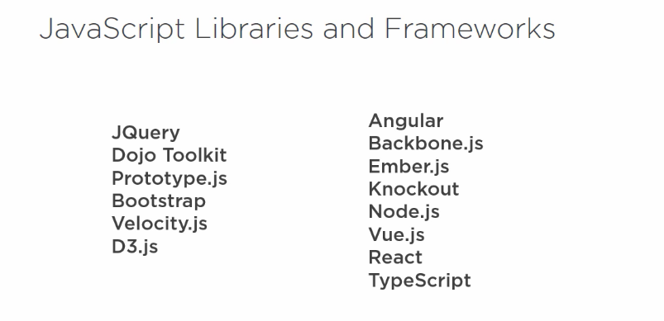

### Thing to remember

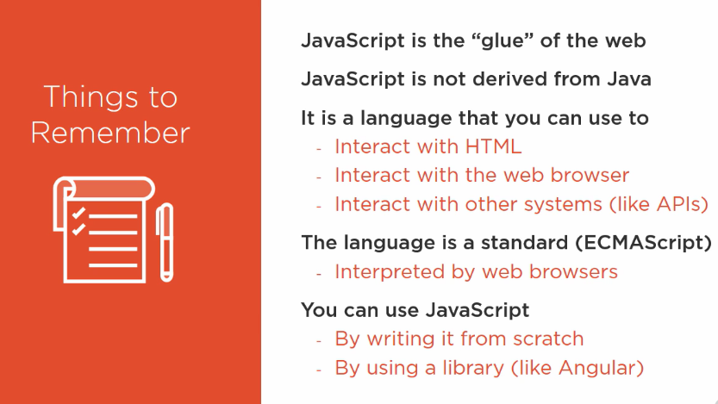

# Where to go from here

